**Name: Blessing James**

**Term: Term 2**

**Student ID: Student 1422759**

**Curriculum: ADSE**

**Employee Records Management System using JAVA**

horizontal line

# Placeholder image

**Project Report**

**Certificate of Completion**

This certifies that the Employee Records project has been successfully completed by Blessing James.

**Table of Contents**

1. Acknowledgment
2. Synopsis
3. Problem Definition
4. Analysis
5. Algorithms
6. Task Sheet
7. Project Review and Monitoring Report
8. Final Checklist
9. Screenshots
10. Conclusion

**###1.Acknowledgement**

First and foremost, I express my gratitude to God for His blessings, guidance, and inspiration throughout the development of the Employee Records system. His unwavering support and grace have been the foundation of my endeavors.

I would also like to extend my sincere appreciation and gratitude to our instructors. Their wisdom, expertise, and guidance have been instrumental in shaping our understanding of software development and providing valuable insights throughout the development process. We are grateful for their patience, encouragement, and dedication to our growth.

**###2.Synopsis**

The Employee Records system is a user-friendly software application designed to streamline and automate the management of employee records within an organization. It provides a centralized platform for storing, updating, and accessing employee information, improving efficiency and data accuracy. Key features of the system include adding, deleting, modifying, searching, and displaying employee records, as well as performing record count operations. With a focus on enhancing HR processes, the Employee Records system facilitates effective employee data management.

**### 3. Problem Definition**

The Employee Records program is designed to maintain employee information. It provides functionalities such as adding, deleting, modifying, searching, displaying all records, and counting records. The data is stored in a text file and remains accessible across program executions. The program also includes proper validation of data fields and ensures the uniqueness of employee numbers.

**###4.Analysis:**

The analysis phase of the Employee Records system involved thorough research and requirements gathering to ensure a solid foundation for the system's development. Key findings include:

Core Functionalities: Based on the gathered and specified requirements, essential functionalities were identified, such as adding, deleting, modifying, searching, and displaying employee records. Additionally, performing record count operations was recognized as crucial for the analysis.

The comprehensive analysis conducted during this phase enabled the development of the Employee Records system that meets the specific requirements of the organization, enhances HR processes, and ensures effective employee data management.

**### 5. Algorithms**

The following algorithms are used to implement the functionalities of the Employee Records program:

**- **ADD**:** This algorithm adds a new employee record to the file.

**- **DELETE**:** This algorithm removes an existing employee record from the file.

**- **MODIFY**:** This algorithm updates the information of an existing employee record in the file.

**- **SEARCH**:** This algorithm searches for an employee record based on the provided criteria (First Name, Last Name, or Department).

**- **Display All Records**:** This algorithm retrieves and displays all employee records from the file.

**- **COUNT**:** This algorithm counts and returns the total number of employee records in the file.

**### 6. Task Sheet**

During the development of the Employee Records program, the following tasks were performed:

| **Task** | **Time Spent** | **Challenges and Difficulties** |
| --- | --- | --- |
| Designing | 3 days | Determining the optimal data structure for storing employee records |
| Coding | 10 days | Implementing file I/O operations and data validation |
| Testing | 3 days | Creating comprehensive test cases and handling edge cases |
| Debugging | 3 days | Resolving issues related to file handling and search algorithms |
| Documenting | 1 day | Writing detailed comments |

**### 7. Project Review and Monitoring Report**

The Employee Records project was reviewed based on the following metrics:

**- Code quality:** The codebase was well-structured and followed coding standards.

**- Readability:** The code was readable and maintainable, with proper naming conventions and comments.

**- Maintainability:** The program was designed to be easily maintainable and extendable.

**- Efficiency:** The program demonstrated good performance and efficiency in handling employee records.

**- Reliability:** The program had robust error handling and exception management.

**- Usability:** The user interface was intuitive, allowing users to easily perform operations on employee records.

**- Functionality:** The program met all the specified requirements and provided the desired functionalities.

**### Reviews**

Based on the review, the following suggestions for improvement and future enhancements were identified:

- Implement additional validation checks for data fields to ensure data integrity.

- Enhance the search functionality to allow for more flexible and refined searches.

- Implement sorting options for displaying records based on different criteria.

- Improve the user interface to provide a more interactive and user-friendly experience.

- Implement data backup and restore mechanisms to prevent data loss.

**### 8. Final Checklist**

The Employee Records program was thoroughly reviewed and verified against the following checklist:

- The program effectively solves the problem of maintaining employee records.

- The program is free of errors, bugs, and vulnerabilities.

- The program follows the coding standards and conventions of the chosen programming language.

- The program's documentation, including comments, is complete and accurate.

- The program has been thoroughly tested and validated against test cases.

**###9.Screenshots**

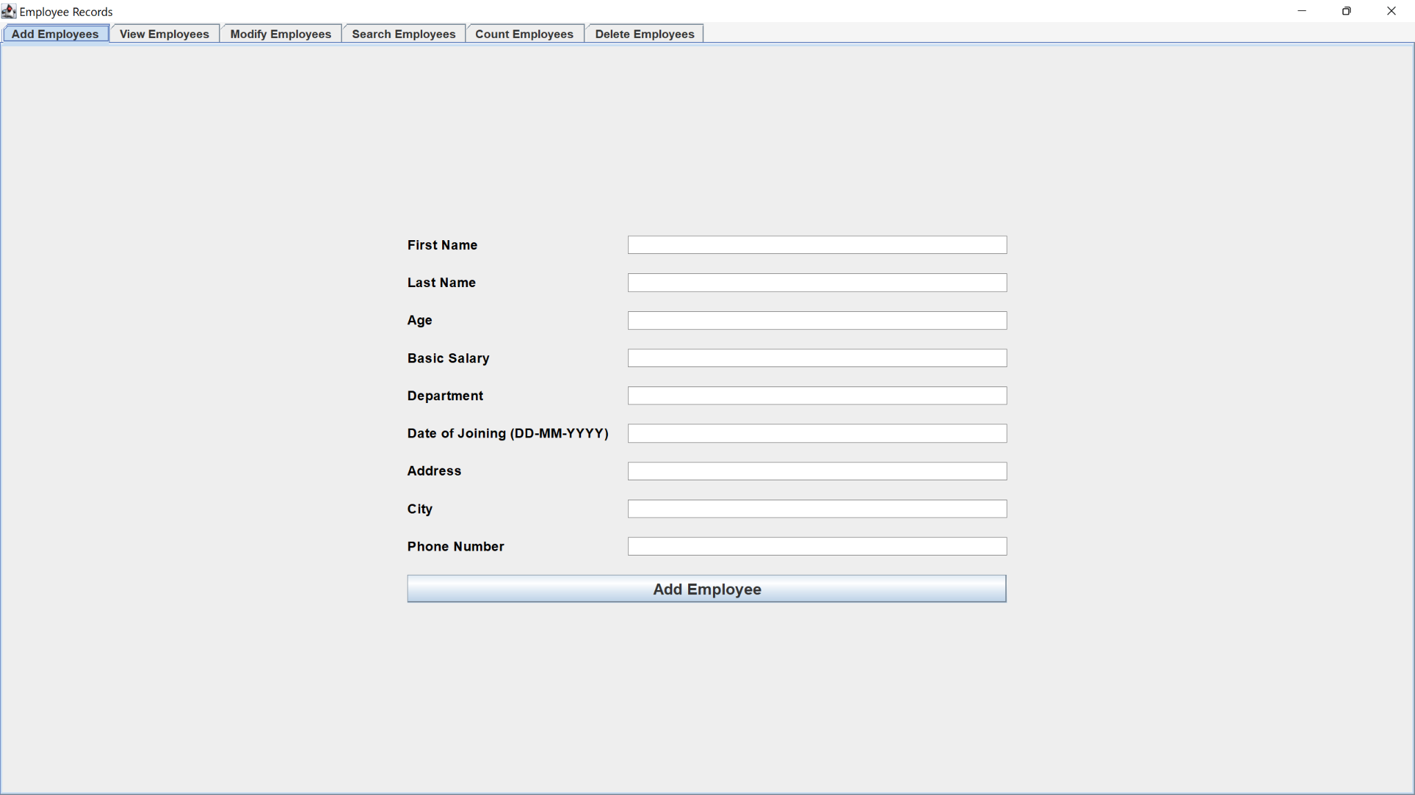

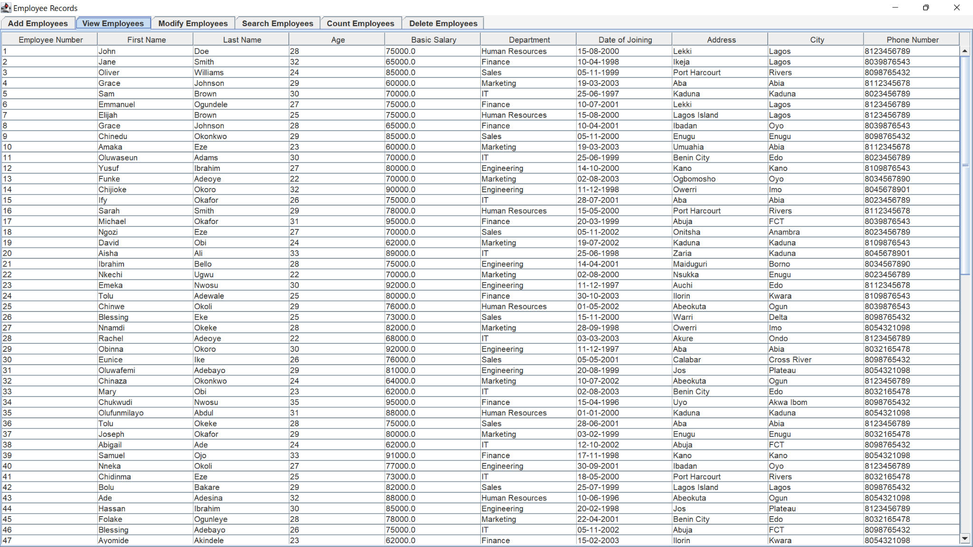

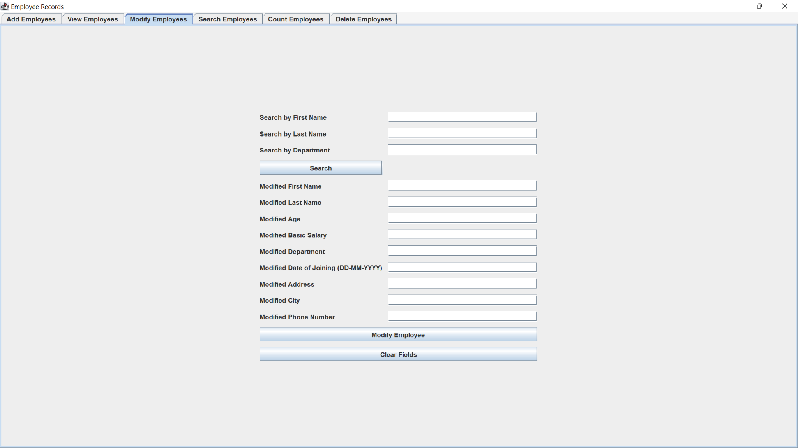

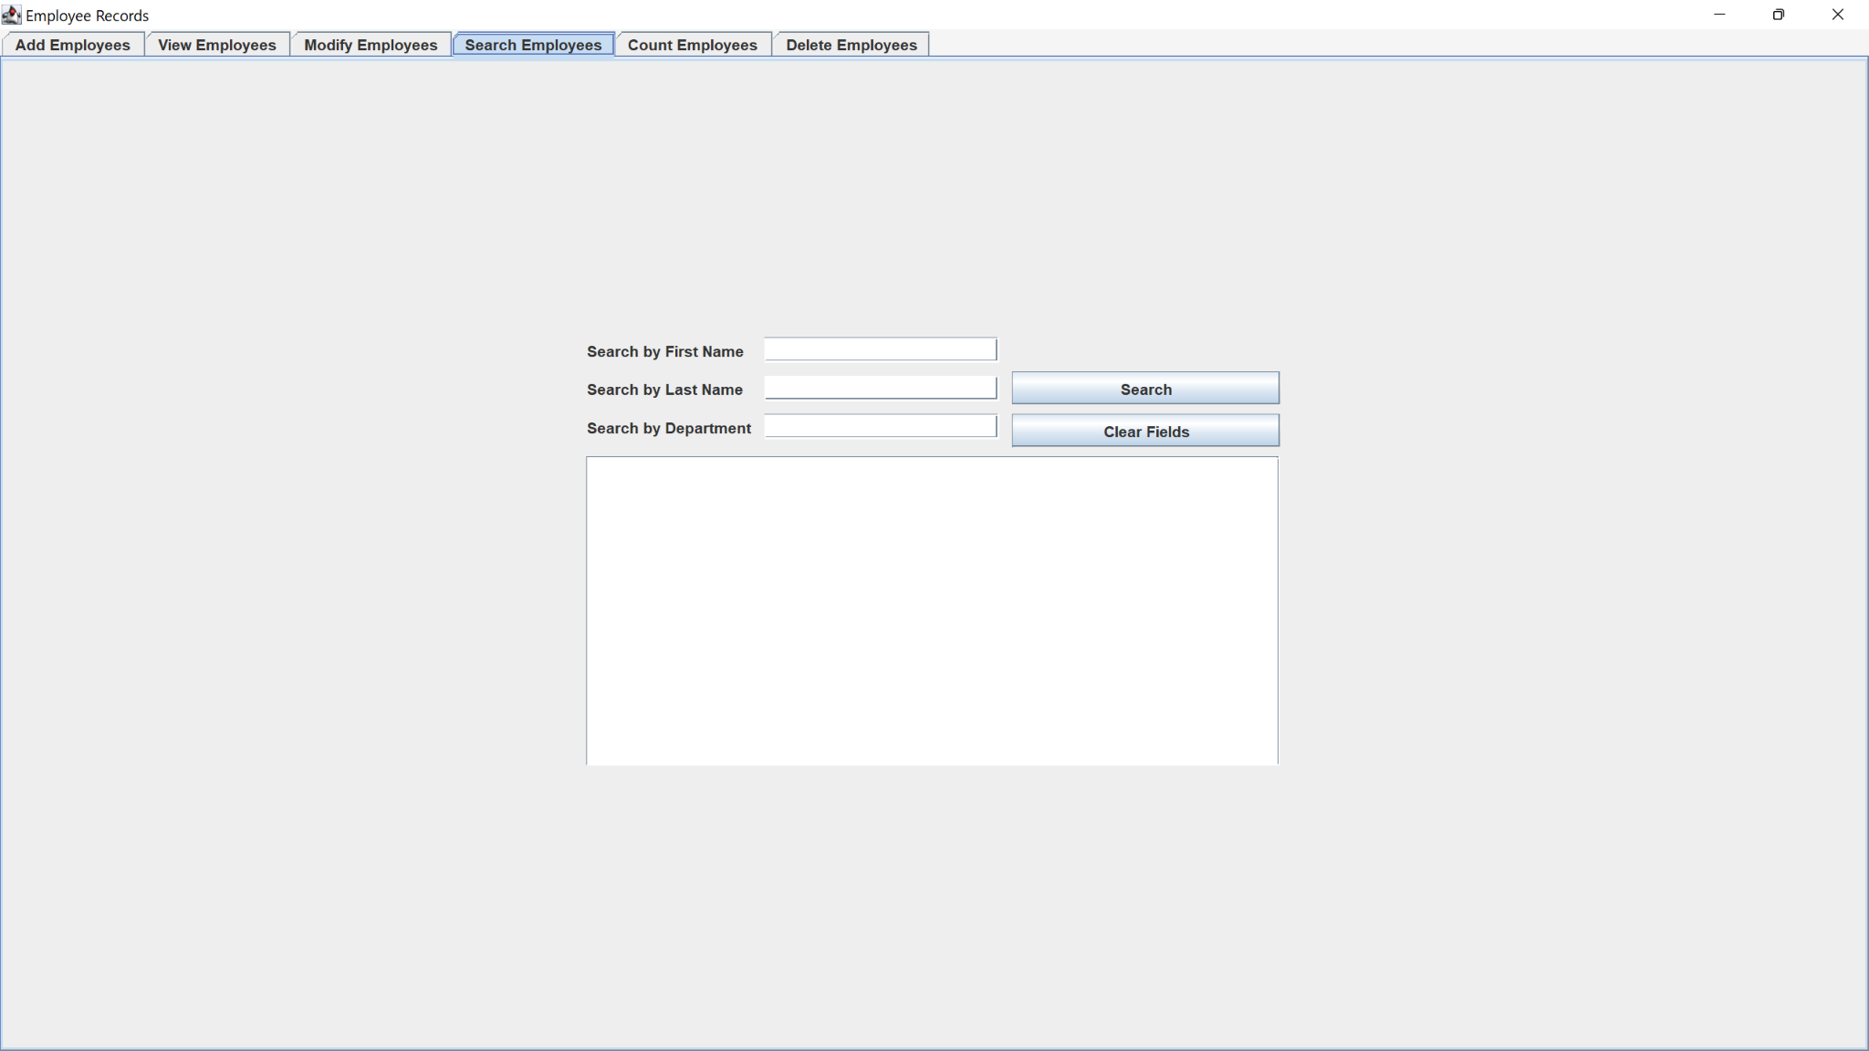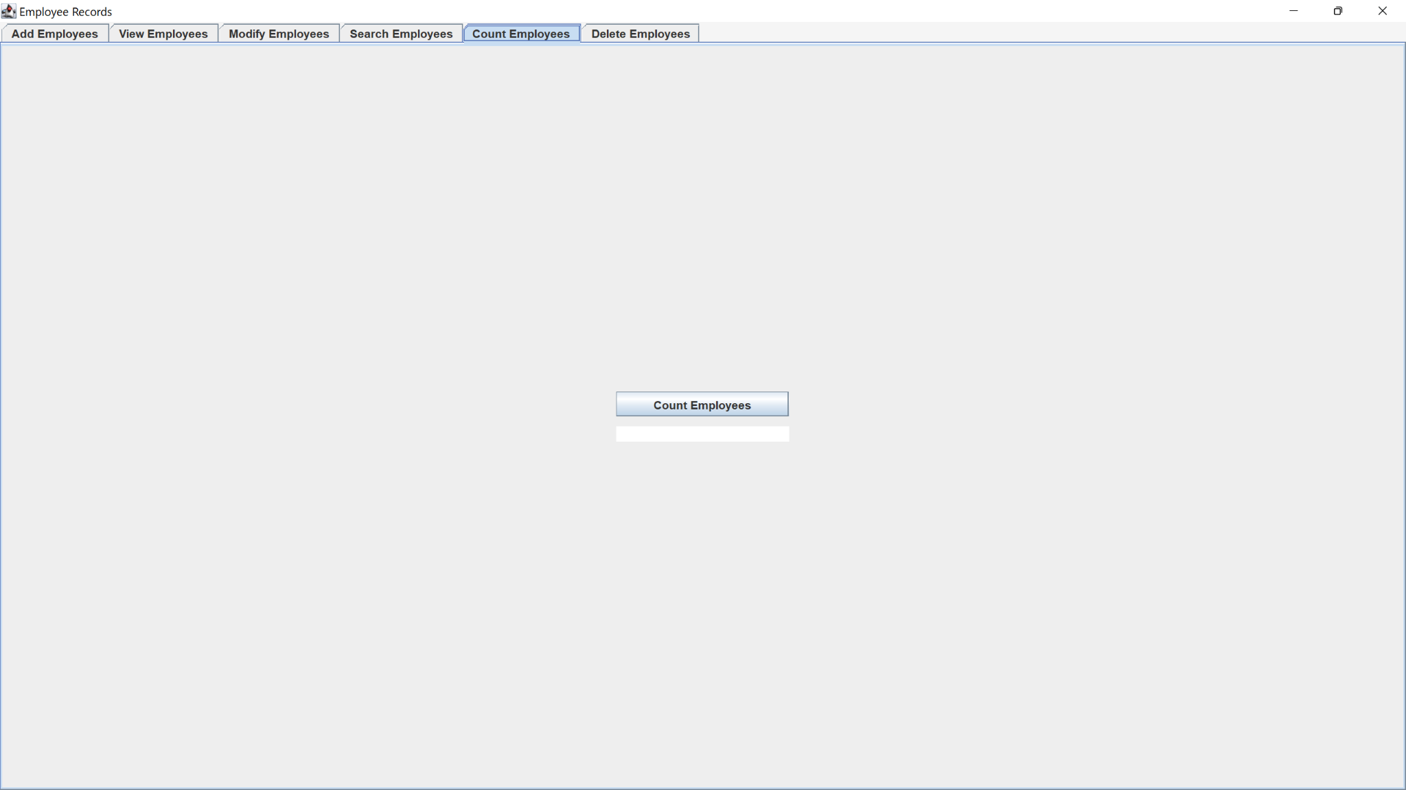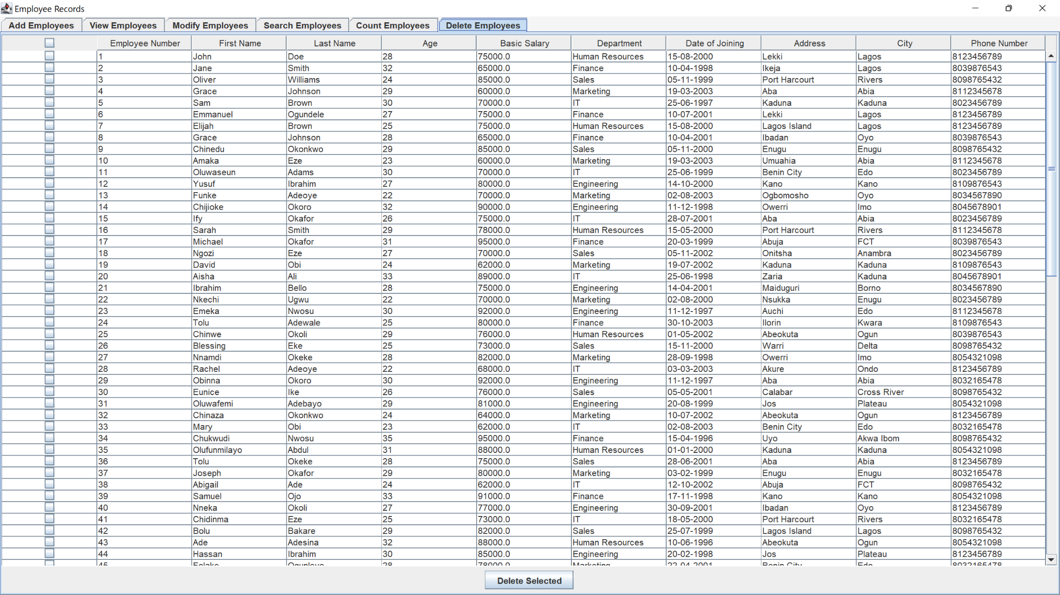

**###10.Conclusion**

This concludes the project report for the Employee Records program. The program successfully maintains employee records, provides essential functionalities, and meets the specified requirements. The documentation and review ensure the program's quality, usability, and future improvement possibilities.